**Technical Document Module 2**

## **M02 L06**

## **M02 L07**

* **Selection Sort**
  + A sorting algorithm in which each value, one at a time, is placed into its final sorted position in the list.
    - Finds the smallest element in the list and places it in its correct position
    - Repeats this process for each subsequent position
      * Better for bigger arrays

**Example**

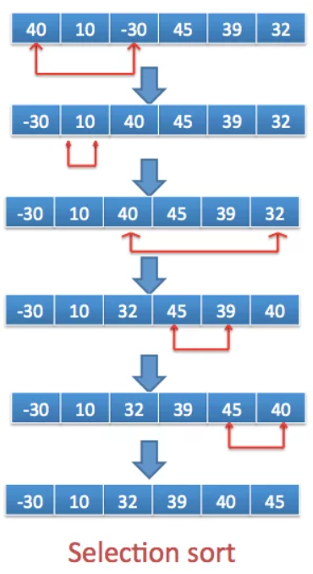

* **Bubble Sort (Sinking Sort)**
  + A sorting algorithm in which values are repeatedly compared to neighboring elements (values) in the list and their positions are swapped if they are not in the correct order.
    - The smallest values "bubble" to the top and the largest values "sink" to the bottom
    - Makes multiple passes through the array

**Example**

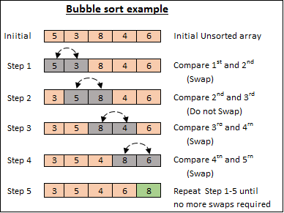

* **Insertion Sort**
  + A sorting algorithm that maintains a sorted sublist in the lower positions of the list. Each new item is then inserted back into the previous sublist, expanding the sorted sublist by one item
    - * Better for smaller or more sorted arrays
    - Each new item is inserted back into the previous sublist
    - The sorted sublist expands by one item in each iteration
    - ***Sorted Sublist -*** *A portion of the array that is already arranged in the correct order (usually in ascending order) during the sorting process.*

**Example**

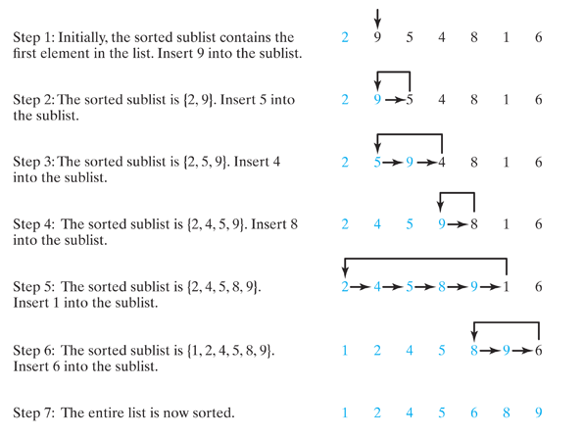

* **Test-Driven Development (TDD)**
  + A software development process where test cases are written before the code itself. This helps ensure that the code meets the desired functionality.
    - Done on paper or digitally

**Example**

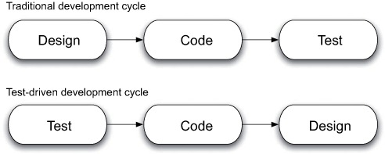

## **M02 L07**

* **Linear Search (Sequential Search)**
  + A search array that checks every single index starting from 0 to find the ‘key’ in the array
    - Very useful for small and unsorted arrays

**Example**

* **Binary Search**
  + A search array that cuts the array in half to find the middle and continue to repeat till it finds the ‘key’
    - It's using “(low + high)/2 = mid” to find the middle of the array
    - Can be used in sorted arrays

**Example**

* Array Class

## **M02 L12**

Agile Software Development

* + **Agile-** having a resourceful and adaptable character, almost like planning a big trip

## M02 L13

Big-O Notation

* A type of rating system for algorithms